Spring Data JPA - Quick Example

Country table creation
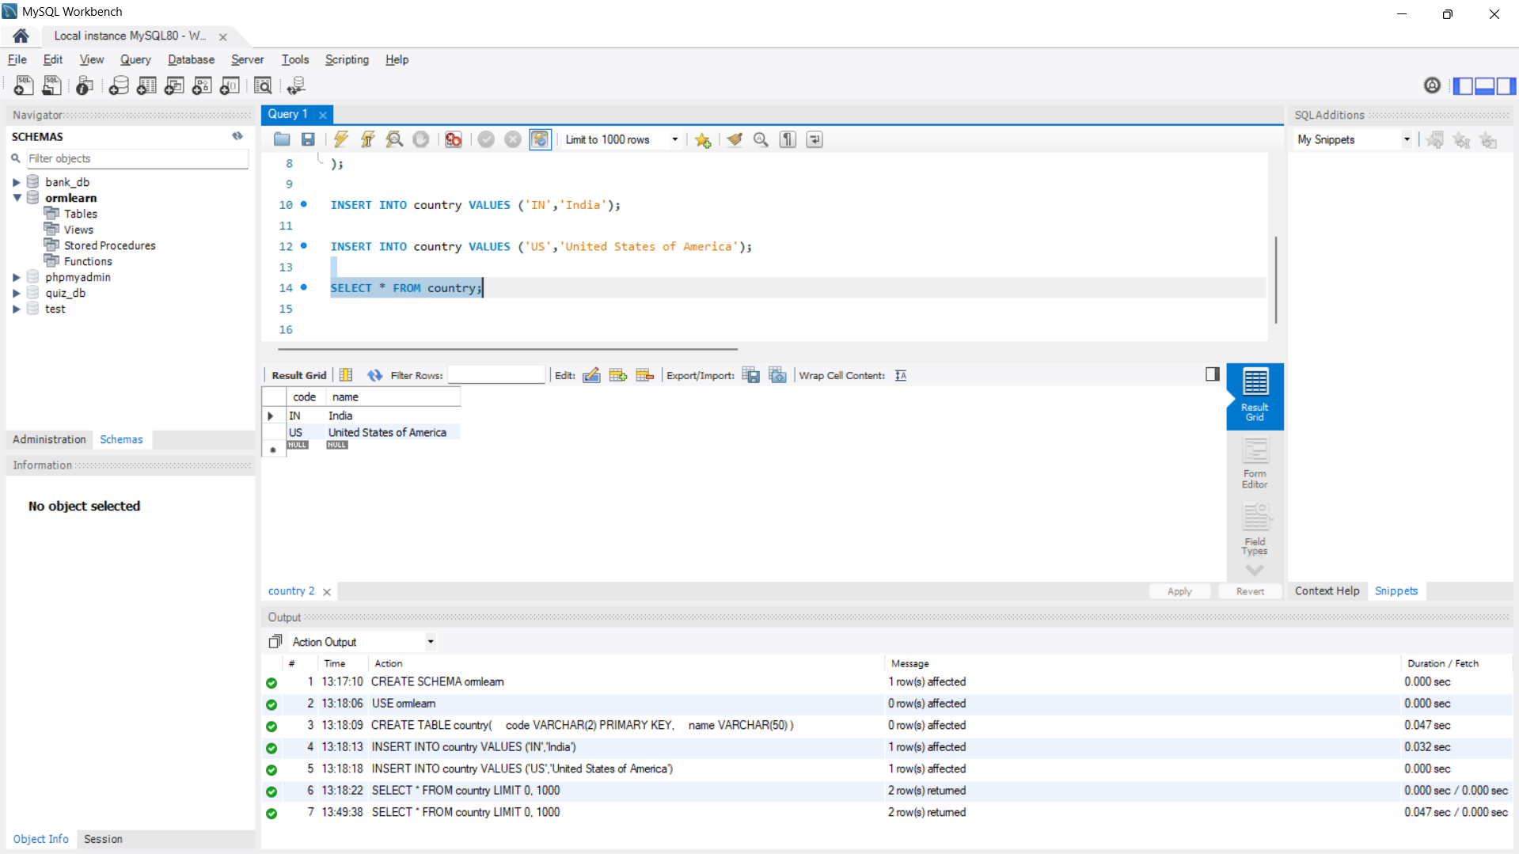

Testing in OrmLearnApplication.java

package com.cognizant.ormlearn;

import java.util.List;
import org.slf4j.Logger;
import org.slf4j.LoggerFactory;
import org.springframework.boot.SpringApplication;
import org.springframework.boot.autoconfigure.SpringBootApplication;
import org.springframework.context.ApplicationContext;
import com.cognizant.ormlearn.model.Country;
import com.cognizant.ormlearn.service.CountryService;

@SpringBootApplication
public class OrmLearnApplication {
private static final Logger LOGGER =
LoggerFactory.getLogger(OrmLearnApplication.class);
private static CountryService countryService;
public static void main(String[] args) {
ApplicationContext context =
SpringApplication.run(OrmLearnApplication.class, args);
countryService =
context.getBean(CountryService.class);
LOGGER.info("Inside main");
testGetAllCountries();
}

private static void testGetAllCountries() {
LOGGER.info("Start");
List<Country> countries =
countryService.getAllCountries();
LOGGER.debug("countries={}", countries);
LOGGER.info("End");
}
}

OUTPUT 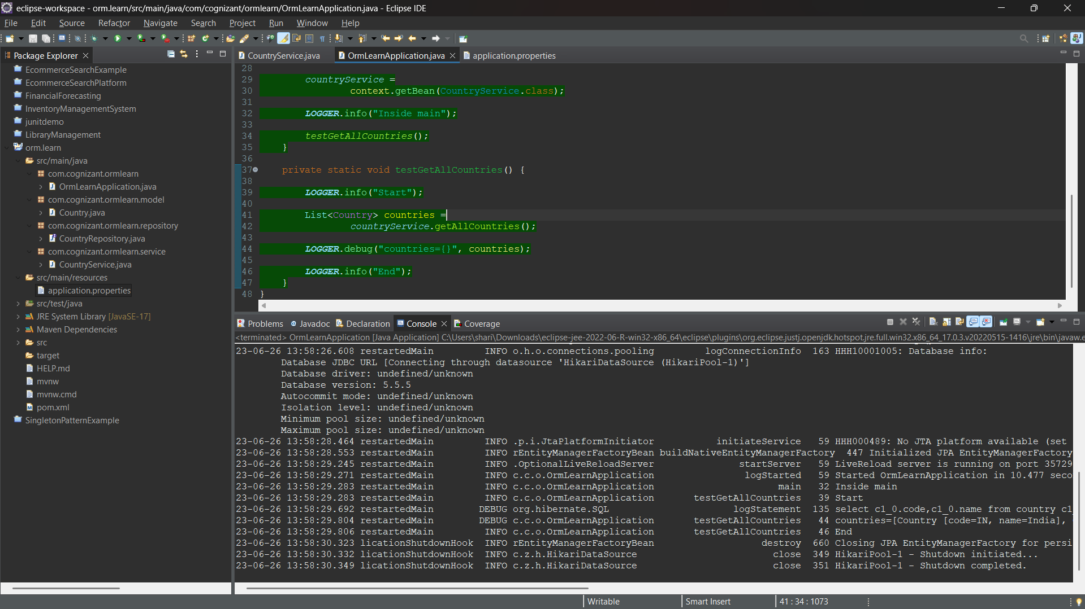

Difference between JPA, Hibernate and Spring Data JPA

Java Persistence API (JPA)
JPA (Java Persistence API) is a specification that defines how Java objects are mapped to relational databases.
Features:
- Standard specification (JSR 338)
- Provides annotations such as @Entity, @Table, @Id and @Column
- Does not contain implementation code
- Requires an implementation provider
Examples of JPA Providers:
- Hibernate
- EclipseLink
- OpenJPA

Hibernate
Hibernate is an Object Relational Mapping (ORM) framework that implements the JPA specification.
Features:
- Provides actual implementation of JPA
- Converts Java objects into database records
- Handles CRUD operations
- Generates SQL queries automatically
- Supports caching and transaction management
Advantages:
- Reduces manual SQL coding
- Supports database portability
- Improves productivity

Spring Data JPA
Spring Data JPA is a framework built on top of JPA implementations such as Hibernate.
Features:
- Reduces boilerplate code
- Provides Repository interfaces
- Automatically generates CRUD methods
- Integrates with Spring Framework
- Simplifies transaction management
Advantages:
- Minimal code
- Faster development
- Better maintainability

Relationship Between Them
JPA → Specification
Hibernate → Implementation of JPA
Spring Data JPA → Abstraction layer over Hibernate/JPA
Application
↓
Spring Data JPA
↓
Hibernate
↓
JPA Specification
↓
Database

Conclusion
JPA is a specification that defines persistence standards. Hibernate is an implementation of JPA that performs ORM operations. Spring Data JPA is built on top of Hibernate and reduces boilerplate code by providing repository-based database access. Therefore, Spring Data JPA offers the simplest and most productive approach for database operations in Spring applications.

